

**KOLEJ PERMATA@PINTAR NEGARA UNIVERSITI KEBANGSAAN MALAYSIA  
 DIGITAL INNOVATOR PROGRAMME (DIP)  
 ASSESSMENT 2 SEMESTER 2 2024/2025**

**COMPUTER SCIENCE (CS) SQL EXERCISE  
 WRITTEN REPORT ON LIBRARY DATABASE (10%)**

PREPARED BY: AKIF FUDHAIL BIN MOHD FAIZAL 1K5  
DATE OF SUBMISSION: 17 DECEMBER 2024

# 

**GUIDELINES FOR CONTENTS**

A **softcopy** on a report consists of:

i. A pdf format and rename as: *Tang_Chee_Keong_1K5*.pdf

ii. Cover page: Name, Matric, Class

iii. Format style:

Font style: **Times New Roman**

Font size: **12**

Paragraph alignment: **justified**

Line spacing: **1.15**

#### 

#### **TABLE OF CONTENTS**

**TABLE OF CONTENTS 2**

**1.0 TABLE STRUCTURES 2**

1.1 Creating a table 2

**2.0 REQUIRED OPERATIONS 3**

2.1 Data Entry 3

2.2 Basic Queries 4

2.3 Data Manipulation 5

**________________________________________________________________________________________________________**

#### **1.0 TABLE STRUCTURES**

##### **1.1 Creating a table**

To create a table of “books” with

* book_id (Primary Key)
* title
* author
* borrowed_date (YYYY-MM-DD)

We can create the following code in HeidiSQL.

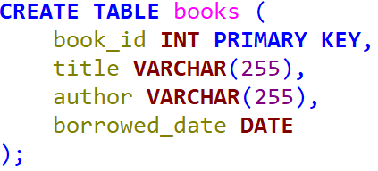

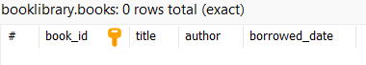

**________________________________________________________________________________________________________**

#### **2.0 REQUIRED OPERATIONS**

##### **2.1 Data Entry**

To add values inside the table “books”, we can use “INSERT INTO books VALUES ()”.

But since we already have auto increment in book_id, we need to specify that we are only adding values into title, author, and borrowed_date.

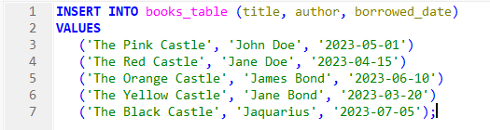

So, our table now looks like this, with additional rows.

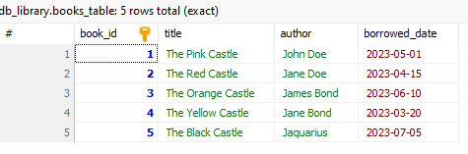

##### **2.2 Basic Queries**

To find books by a specific author, we can select everything from the table (like the example above), but this time, we have a WHERE clause.



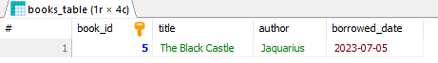

To find books that are borrowed on a specific date, we can use the same method as the above. This time having the WHERE clause in a different column.



Using the same method as above, we can also find the books borrowed after a specific date, using a different operator “ > “.

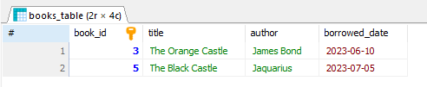

##### 

##### **2.3 Data Manipulation**

To update the borrow date of a book, we can use “UPDATE books”. Then, set the borrow_date to be any date (YYYY-MM-DD)

Make sure to add a WHERE clause to not make the change to all of the books.

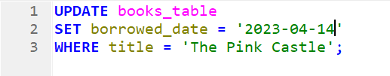

Before updating books:

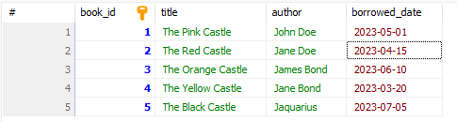

After updating books:

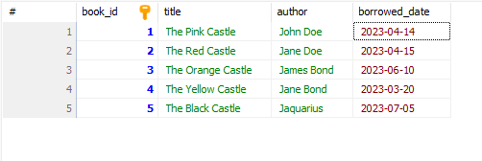

To delete a book, we can use “DELETE FROM books”. Make sure to add a WHERE clause to not delete every book in “books”.

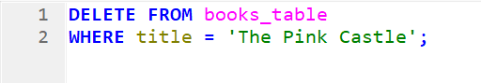

Before deleting from books:



After deleting from books:

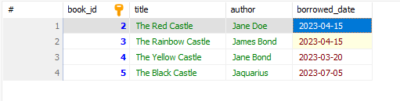

To re-add a deleted book, you can use “INSERT INTO books (title, author, borrowed_date) VALUES ()” and insert the same data again.

